|  |  |
| --- | --- |
| **Project Case** | Description: LogoBINUS-University |
| C |
| **Periode Berlaku** Semester Ganjil 2022/2023  ***Valid on*** *Odd Year 2022/2023* | **Software Laboratory Center**  **Assistant Recruitment 23-1** |

***Note:******Please focus on the main logic and main feature!***

*(Splash screen and design are not scored)*

## Soal

*Case*

**C Space Invader**

Space Invaders is a very simple game by modern standards, but it was a technological marvel in its time. Space Invaders was a worldwide success and paved the way for a generation of shooting games that became extremely popular.You as a developer asked to make a Space Invader with C Programming Languange.

* **Main menu**
* This menu contains of 5 menus, which are **New Game**, **Load Game**, **Setting, How to Play, and Exit.**
* **Prompt** userto **input chosen menu**. **Validate** the input must **between 1 and 5 inclusively**.

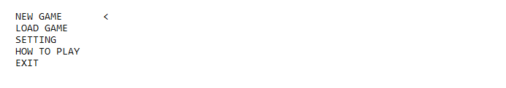

Figure 1. Home Page

1. If user choose **New Game** (**Menu 1**), then:
   * **Prompt** user to **input username**. **Validate** the data must more than **3 characters exclusively**
   * Validate the **username** must **not exists.**



Figure 2. Input Username



Figure 3. Username Validation

* + **Direct** user to **game page.**

1. If user choose **Load Game** **(Menu 2)**, then:
   * **Show** all available player at **‘player.dat’**
   * **Prompt** user to **input chosen menu**. **Validate** the input must between **1 and total player + back inclusively.**
   * If load data **success, direct** user to **game page**.
   * If user choose **back, direct** to **main menu**.

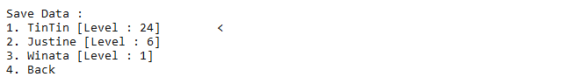

1. If user choose **Setting (Menu 3)**, then:
   * **Show** all available **input**.

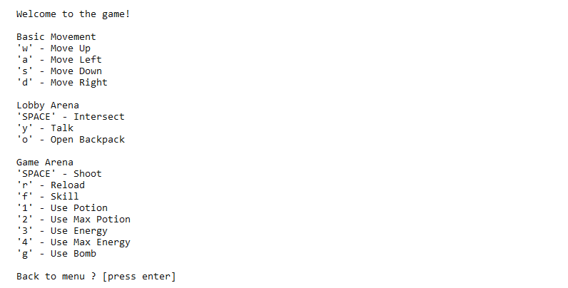

1. If user choose **How to Play (Menu 4)**, then:
   * **Show** main objective of the game.

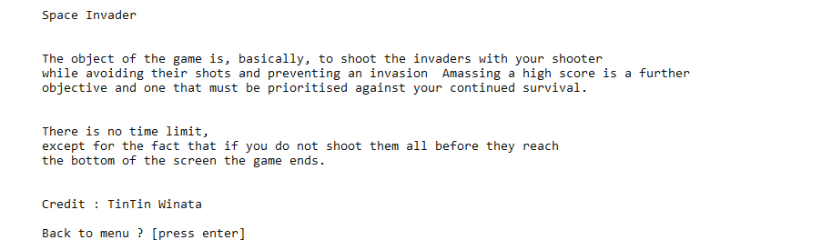

1. If user choose **Exit (Menu 5)**, then:
   * **Display** Logo and motto

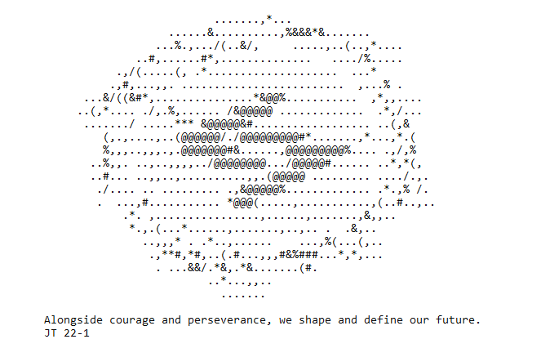

* **Gameplay**
* **Lobby**
  + Spawn user at the **bottom of the Lobby**.
  + Display **lobby, user position,** and **user information**.
  + Print **NPC** with the given symbol.
  + If user stands the **middle of lobby map** (fountain), then :
    - Tell **user** can do **interact** by **typing ‘SPACE’ key.**
    - **User** can go to the **game arena**
* Below is some information of map symbols.

|  |  |
| --- | --- |
| Symbol | Meaning |
| | | Board |
| \ or / | Door |
| - | Closed Door |
| # or = | Wall |
| . | Pillar |
| P | Player |
| U | Upgrade Shop |
| I | Item Shop |
| W | Spaceship Station |

Table 1. Map information

* Prompt user to input **key W A S D** (Case Insensitive) (Up, Left, Down, Right) to **move**.
* Validate that user **cannot pass through walls and pillars**.
* If user type key **O** (Case Insensitive), display user’s **backpack information**.

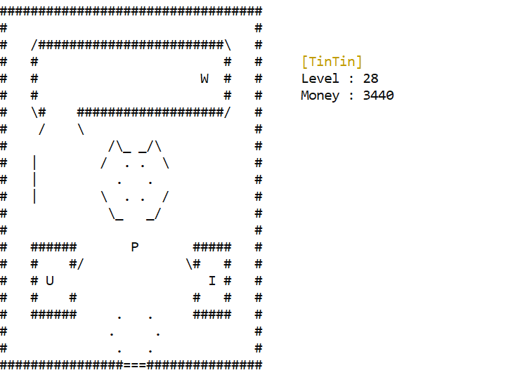

* If user position is at **U (upgrade Shop**), then:
  + Tell user can do interact by typing ‘SPACE’ key.
  + If user press ‘SPACE’, then user will interact to NPC, NPC will ask user to go the shop menu.
  + If user press ‘y’, then:
    - **Display** user **upgrade shop menu**.
    - **Prompt** user to **input chosen menu. Validate** the input must **between 1 and 4 inclusively**.
    - If user choose upgrades attribute **validate user money is enough and validate attribute is not at the maximum level**.
      * If **money is not enough** or **attribute is not at the maximum level**, **display error message**.
      * If **money is enough** and **attribute is not at the maximum** decrease the **money**,increment the **player attribute by 1**,and **display succesfull message**.
    - If user choose **4**, then **back to lobby**.
  + Remember please validate if you can’t press **‘y’** to open shop if you never interact with NPC.

* If user position is at **I (Item Shop)**, then:
  + Tell user can do interact by typing ‘SPACE’ key.
  + If user press ‘SPACE’, then user will interact to NPC, NPC will ask user to go the shop menu.
  + If user press ‘y’, then:
    - **Display** user **item shop menu**.
    - **Prompt** user to **input chosen menu. Validate** the input must **between 1 and 6 inclusively**.
    - If user choose items, then:
      * **Prompt** user to **input the quantity** to buy.
      * **Calculate total price** by **multiplication** of price and quantity. **Validate** user money is **enough to pay** the **total price**.
      * If user **money is enough**, **reduce user money** by **total priceadd items to** user’s data, and display **succesfull message**. Then **back to lobby**.
      * If money is **not enough**, display **error message.** Then **back to lobby**.
    - If user choose **6**, then **back to lobby**.
  + Remember please validate if you can’t press **‘y’** to open shop if you never interact with NPC.

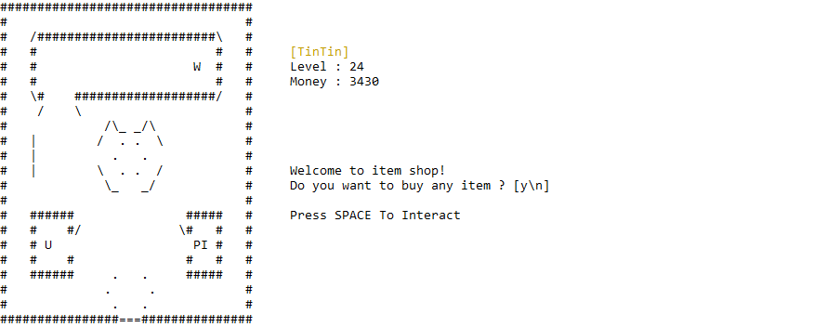

* If user position is at **W (Spaceship Station)**, then:
  + Tell user can do interact by typing ‘SPACE’ key.
  + If user press ‘SPACE’, then user will interact to NPC, NPC will ask user to go the shop menu.
  + If user press ‘y’, then:
    - **Display** current **spaceship**.
    - User can change current spaceship by input **‘A’ to (Left)** and **‘D’ to (Right)**.
    - Remember, there’s **no min or max** **spaceship** validation, if user input **‘D’** when **the current spaceship is last** then **back to first spaceship**.
    - User can **choose the spaceship** by input ‘ENTER’. And return to **lobby**.
  + Remember please validate if you can’t press **‘y’** to open shop if you never interact with NPC.
* Below is some information about **Upgrade Shop**.

|  |  |
| --- | --- |
| Attribute Name | Price |
| HP | $50 |
| Energy | $50 |
| Armor | $30 |

* Below is some information about **Item** **Shop**.

|  |  |
| --- | --- |
| Item | Price |
| Potion | $5 |
| Max Potion | $20 |
| Energy Drink | $3 |
| Max Energy Drink | $15 |
| Bomb | $10 |

* **Shooter Arena**
  + **Direct user information** (spaceship name, score, bullets, hp, energy).
  + Every 3seconds **Random 3 Enemies** with this following criteria :
    - Generate random 1 – 3 for the enemies level.
    - **The direction of enemies is** left to right **and** right to left continously.
  + Below is some information about **Enemy.**

|  |  |  |
| --- | --- | --- |
| Level | Sprite | Damage |
| 1 | \v/ | 10 |
| 2 | \x/ | 20 |
| 3 | \o/ | 25 |

Please run the EXE file to see the sample program.